D Experiment Instructions (for Online Appendix)

# Introduction

Welcome! This is a study of individual decision-making and behavior. The money you earn will be paid to you in cash at the end of this experiment.

This experiment has 4 parts. For each part, we will give you instructions just before it begins. Your choices in one part of the experiment will not affect what happens in any other part. Each part proceeds in rounds. There will be 10 rounds in total. We expect that most participants would be able to complete the experiment in about 30 minutes. The experiment will end with a short questionnaire.

At the end of the experiment, we will draw one of the rounds at random as the **Payment Round.** Each round of the experiment is equally likely to be drawn. Only the decision that you made in that Payment Round will determine your final payoff. Hence you should make every decision as if it is the one that counts, because it might be!

At the start of the experiment, you will be given $25, so with the show up fee included you will have $30 in total. The choices you make within the experiment will determine how much of this amount you may lose. It is impossible to lose more than $25, so your earnings in the worst-case scenario will be exactly your show-up fee of $5.

You are not allowed to talk during the study. If you have any questions, please raise your hand and we will come and answer your questions privately. Please do not use cell phones or other electronic devices until after the study is over. If we do find you using your cell phone or other electronic devices, the rules of the study require us to withhold your completion payment.

Often during this study, you will be shown information or asked to make decisions. After doing so, remember to click the button that says "Continue". The experiment will not proceed until you click that button.

# Task 1: Protection Decision

The first part of the experiment has 6 rounds. In each round, you will make the Protection Decision as described below. Please note that after the instruction screen, there will be a short quiz to make sure you understand the experiment. Please read the instructions carefully.

At the beginning of each round, the computer will randomly draw a ball from the box, which contains white and black balls. The number of balls of each color can vary between rounds. We will not tell you which ball has been selected by the computer, but you will know the number of balls of each color as in the picture below.

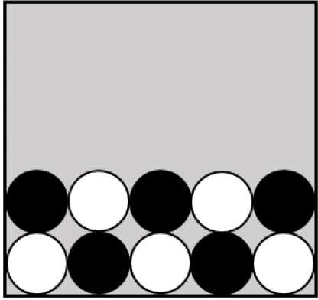

In each round you must decide whether to buy ***Protection. Protection*** costs $5. If you do not buy ***Protection,*** you lose $20 of your starting money if the Ball is Black, but you do not lose anything if the Ball is White. This means that your earnings will be:

* $30-$5=$25 if you buy protection and the ball is White
* $30-$5=$25 if you buy protection and the ball is Black
* $30-$0=$30 if you do not buy protection and the ball is White
* $30-$20=$10 if you do not buy protection and the ball is Black

We would like to ask you a few questions to check your understanding of this task. Please feel free to go back to the instructions if needed.

# Task 2: Informed Protection Task

The second part of the experiment has 6 rounds. Please note that after the instruction screen, there will be a short quiz to make sure you understand the experiment before you can continue to the first round. Please read the instructions carefully.

As in the first part, the computer is going to randomly select one ball from the Box with white and black balls. The computer will show you the contents of the Box but will not tell you the color of the selected ball.

**Within each round, you would receive a hint about the ball's color from a gremlin.** There are three types of gremlins: an honest gremlin always tells the true color of the Ball, a black-swamp gremlin always says that the Ball is black and a white-swamp gremlin always says that the Ball is white. This is how they look:

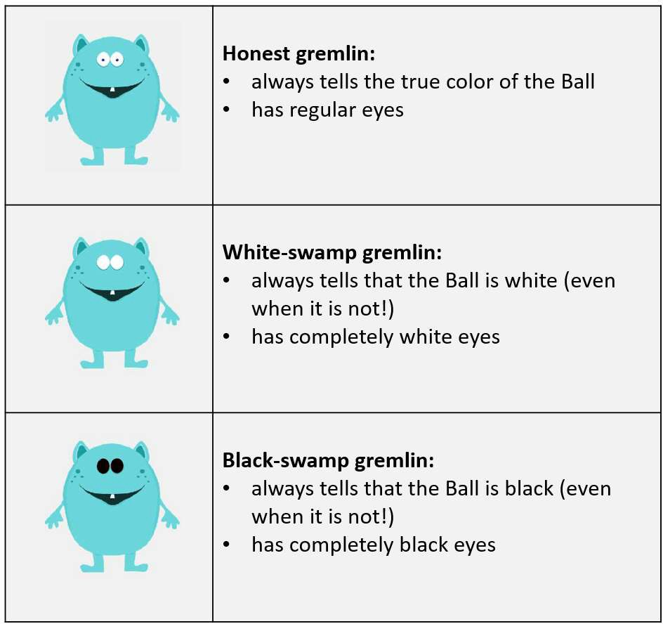

The hints of white-swamp and black-swamp gremlins do not depend on the color of the selected ball. A white-swamp gremlin always says that the Ball is white and would never say that the Ball is black; a black-swamp gremlin always says that the Ball is black and would never say that the Ball is white. Their hints can be correct only by accident.

Suppose, for example, that the Ball is black. Then an honest gremlin would say that the Ball is black. A white-swamp gremlin would say that the Ball is white. A black-swamp gremlin would say that the Ball is black.

On the other hand, if the Ball is white, then an honest gremlin would say that it is white. A white-swamp gremlin would say that it is white. A black-swamp gremlin would say that it is black. Remember that gremlins are just pre-coded computer algorithms and do not intentionally try to help or harm you.

The computer picks the hinting gremlin randomly from a group of gremlins of different types, where each individual gremlin is equally likely to be selected. You will be informed of the mixture of gremlins in this group (similar to the figure below), but you do not know which gremlin is giving the hint.

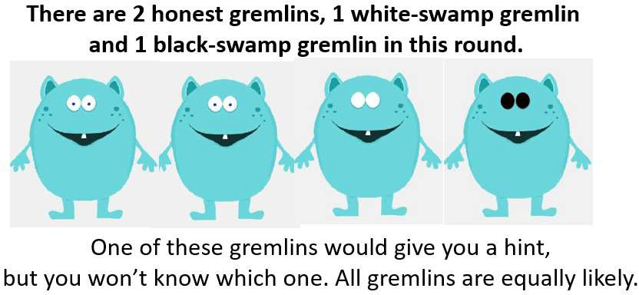

The group of gremlins from which the computer selects the hinting gremlin can change from round to round. For example, in one round, you might have two honest gremlins and one white-swamp gremlin in the group. In another round, you might have three honest gremlins and two black-swamp gremlins. You will see the group's composition before making your decisions.

There are two possible hints: either the gremlin says "The Ball is white!" or it says "The Ball is black!". We would like to know whether or not you would buy protection for each of these possible hints. That is, if the hint you receive from a gremlin randomly selected from that group says the Ball is white, would you buy protection? If the hint you receive says that the Ball is black, would you buy protection?

You will need to figure out on your own how likely it is that the hint is true given the group's composition. For example, if all the gremlins are honest, any hint from a randomly drawn gremlin is true. If all the gremlins are white-swamp or all are black-swamp, then their hints give no information. Most often though, your group will include both honest and dishonest gremlins.

As before, protection costs $5. If you do not buy Protection, you lose $20 of your starting money if the Ball is Black, but you would not lose anything if the Ball is White. This means your earnings will be:

* $30-$5=$25 if you buy protection and the Ball is White
* $30-$5=$25 if you buy protection and the Ball is Black
* $30-$0=$30 if you do not buy protection and the Ball is White
* $30-$20=$10 if you do not buy protection and the Ball is Black

After you tell us your decision for each possible hint, the computer will draw a ball. Then it will record a hint from one randomly chosen gremlin from the group. If the gremlin says that the Ball is white, the computer will implement the choice you made for that hint. If the gremlin says that the Ball is black, the computer will implement the choice you made for that hint. The flow chart below illustrates what happens in each round. You should make your choice for each of two possible hints carefully because either one may determine your payoff if this round is chosen for payment.

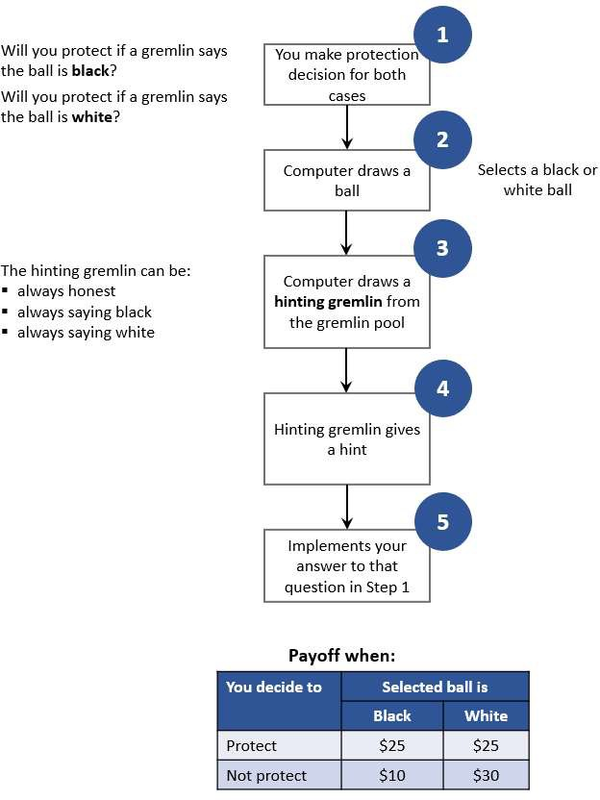

# Task 3: Measuring Chances

In this part of the experiment, you will estimate the chance that the Ball is black based on gremlin's hints. We will first show you: 1) the box with white and black balls and 2) the group of gremlins. Imagine that the computer then randomly picks one ball from the box and one gremlin out of this group who will give you a hint. We will ask you two questions:

1. If this gremlin says that the Ball is white, what do you think are the chances that the Ball is white?
2. If this gremlin says that the Ball is black, what do you think are the chances that the Ball is black?

Your estimate each time will be a percentage between 0 and 100. To illustrate how this works, suppose that all the gremlins in the group are honest. It means that their hints are always true: if a gremlin says that the Ball is white, there is exactly 0% chance of it being black. If a gremlin says that the Ball is black, there is exactly 100% chance that the Ball is black. And the chance that the gremlin says it is Black is exactly the chance that is is Black or the proportion of black balls in the box. This case is very easy, but in most cases, the group of gremlins will include some white-swamp and/or black-swamp gremlins. You should take into account the number of white and black balls and the proportions of each type of gremlin in your group when estimating the chances.

Your payoff depends on the accuracy of your answers. All you have to understand in this task is that you make more money if your guess is closer to the actual probability of the event given your information. You make the most money if your guess is exactly equal to the actual probability of the event. For example, you want to predict the chances that the ball is black if the gremlin says that it is black. If the actual probability is 10% and you choose 20%, you payoff will be $30 with probability 90% and $10 with probability 10%. If you choose 50% instead, your payoff will be $30 with the probability of about 60%>. As you can see, you can win if your estimate is very imprecise, but chances are higher for a more accurate estimate. The next two paragraphs lay out the details of how the payoff is calculated, and you are welcome to read these details.

If any round of this task is chosen as the Payment Round, the computer would, first, draw a ball at random from the Box. Then it would record a hint from one randomly chosen gremlin from the group. Finally, it will draw one random lottery with chances between 0 and 100.

This computer will then calculate your payment based both on the hint, the actual ball color and this random lottery. This is easier to understand through an example. Suppose, that the gremlin hints that the Ball is white and you estimate that the Ball is indeed white with probability 85%. If a computer draws a lottery with chances of 85% and above, then you lose $20 if the Ball is white. If the computer draws a lottery with chances lower than 85%, then you would lose $20 with the chance specified in the lottery.

# Belief Elicitation: rounds

**Suppose that one of the gremlins says that the Ball is white.** What do you think is the chance that the Ball is actually **white?** Please estimate to the best of your ability and make your selection on the slider below:

Impossible Completely certain

0 10 20 30 40 50 60 70 80 90 100

Chance (%) that the Ball is white

**Suppose that one of the gremlins says that the Ball is black.** What do you think is the chance that the Ball is actually **black?** Please estimate to the best of your ability and make your selection on the slider below:

Impossible Completely certain

0 10 20 30 40 50 60 70 80 90 100

Chance (%) that the Ball is black

This concludes the round. You will see the outcome only if this round is selected as the Payment Round in the end of the experiment.

# Task 4: Value

Were gremlins helpful for you? How much would you pay for their hints if given an opportunity?

In this task, you can buy a hint before making a protection decision. As before, the hint will come from a gremlin which is randomly selected from a group of gremlins of different types. We will show you the group composition, but not the type of the hinting gremlin.

After seeing the group of gremlins, please think about the prices you are willing to pay for the hint. You will then select all acceptable prices by filling a table such as this:

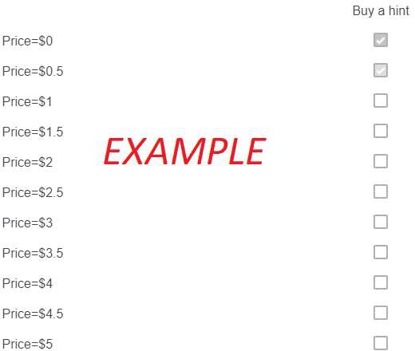

In this table, you select all the prices which you are willing to pay to receive a hint. For example, if you are willing to pay no more than $0.5, then the first and the second rows in the table should be selected as shown in the example above. If you are willing to pay no more than $3, all the rows from the first to the seventh one should be selected. For your convenience, you just need to select the maximum price you are willing to pay for the hint and the system will automatically select all prices lower than that chosen price. You can always unselect the prices by clicking on their checkboxes.

In each round, you will have a different group of gremlins. There are also six rounds in this part of the experiment. You will also have to answer a short quiz before proceeding to the rounds to make sure you understand the experiment. Please read the instructions carefully.

**Payoff Calculation.** If this the Payment Round, the computer will randomly select one of the prices from the Table. If you chose to buy a hint at this price, you would go through one round of the Informed Protection Task. You will make a Protection decision after receiving a hint from the gremlin. We will subtract the selected price from your payoff in that round. Note, that the price you are paying does not affect the hint's quality.

If you opted not to buy a hint at this price, you would go through one round of the Blind Protection task. In other words, you would make a Protection decision without a hint.



For example, suppose that you fill the table as shown above and this round is the Payment Round. If the computer randomly selects price $0.5 (the second line), you will pay $0.5 and go through one round of the **Informed Protection:** you will receive a hint from one of the gremlins and then choose to protect or not. Your payoff would be equal to what you would have received from the Informed Protection round minus the price of the hint. In this example, if you do not protect, then your payoff will be $30-$0.5=$29.5 if the Ball is white and ($30-$20)-$0.5=$9.5 if the Ball is black. If you decide to protect, your payoff will be ($30-$5)-$0.5=$24.5 for any color of the Selected Ball.

If, for example, the computer randomly selects $1 (line 3) instead of $0.5, you will go through one Blind Protection round and this round would determine your payoff. You will neither pay $1 nor receive a hint, because you did not want to pay this price for a hint based on your selections in the Table. The computer would calculate your payoff in the same way as in the Part 1 of the experiment (Blind Protection).

**Suggestions.** You should consider the composition of gremlins when selecting the prices to pay. For example, you might have only white-swamp gremlins in the group. Because white-swamp gremlins always say that the Ball is white, their hints are worthless, and most people would not pay anything for them. On another hand, a hint from a group of honest gremlins is more valuable because it tells you the Ball's color with certainty.

It is always in your best interest to select all the prices below or equal to your maximum price. Suppose, for example, that you want to pay any price up to $3 for a hint from a certain group of gremlins. If you do not select the price of $2 and this price is randomly chosen by the Computer, you would have to make the protection decision without a hint even though you prefer to pay $2 to get one. On another hand, if you select the price of $5, you might have to pay $5 which is $2 more than the maximum price you are willing to pay.